**Independent Investigation**

Overview:

This document contains the independent analysis of the acceptance of coffee coupons by drivers based on the data provided.

1. Acceptance of coffee coupons by Time.

Analyzed the acceptance of coffee coupons based on time of the day. The conclusion was that the acceptance rate in the morning and during evening times were more than other times of the day. This is an indication that drivers during morning or evening commute are likely to accept the coupon.

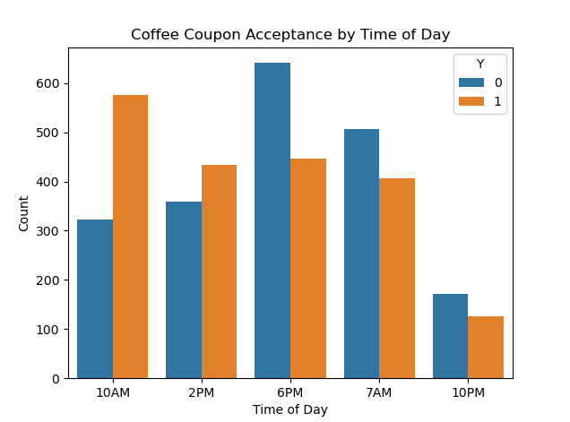

1. Acceptance of coffee coupons by Age.

Analysis indicated that drivers between the ages 20 and 30 have higher acceptance rates. So most likely younger drivers are likely to relax over coffee for casual purposes or like to try new coffee places.

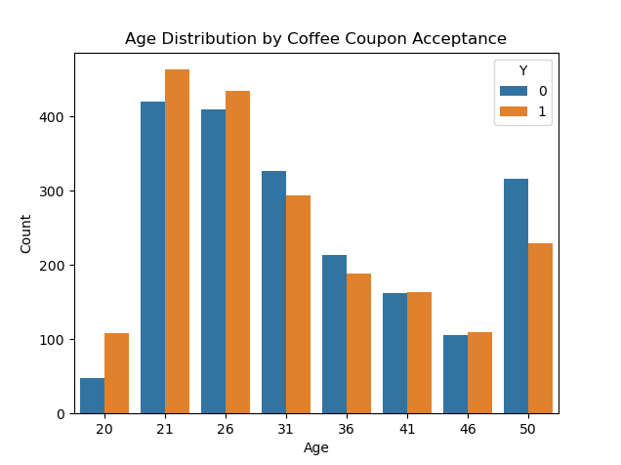

1. Acceptance of coffee coupons by Destination.

Drivers who were in no urgency to reach a destination showed higher acceptance rates. So likely this is an indicator again that they are more likely to relax over coffee or have a casual chat.

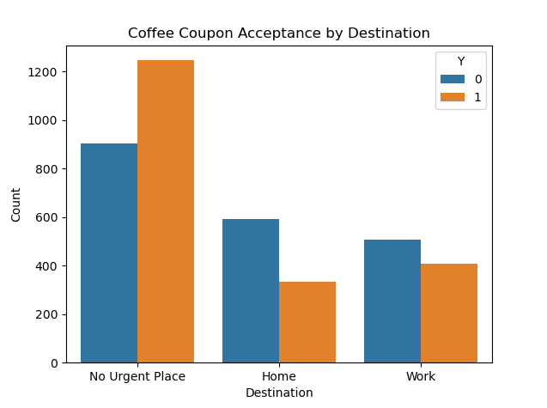

1. Acceptance of coffee coupons by Frequency

Drivers who have a history of visiting coffee shops more frequently per month showed higher rates of acceptance.

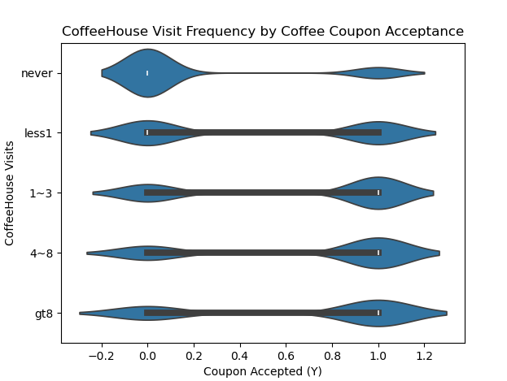

**Summary**:

Based on the visualizations and statistical analysis, the hypotheses about the characteristics of drivers who accept coffee house coupons:

1) Morning Commute: Drivers who are commuting to work and receive the coupon in the morning might be more likely to accept it.

2) Frequent Coffee Drinkers: Those who frequently visit coffee houses are more likely to be interested in coffee coupons.

3) Younger Age Groups: Younger drivers might be more receptive to coffee coupons, potentially due to higher coffee consumption or a greater tendency to try new coffee shops.

5) Casual drivers: Drivers who are not in rush to any destination are more likely to accept coffee coupons, potentially to take a break or relax.

4) Destination and Time: The combination of destination (e.g. work or no urgent place) and time of day (e.g morning and evening) could be a strong predictor of coffee coupon acceptance.

If we are able to target coupons likely to these target groups, we will increase the chances of acceptance of the coupons.